Module 12: Get started with AI-powered info extraction in Azure

Azure AI services for information extraction
- 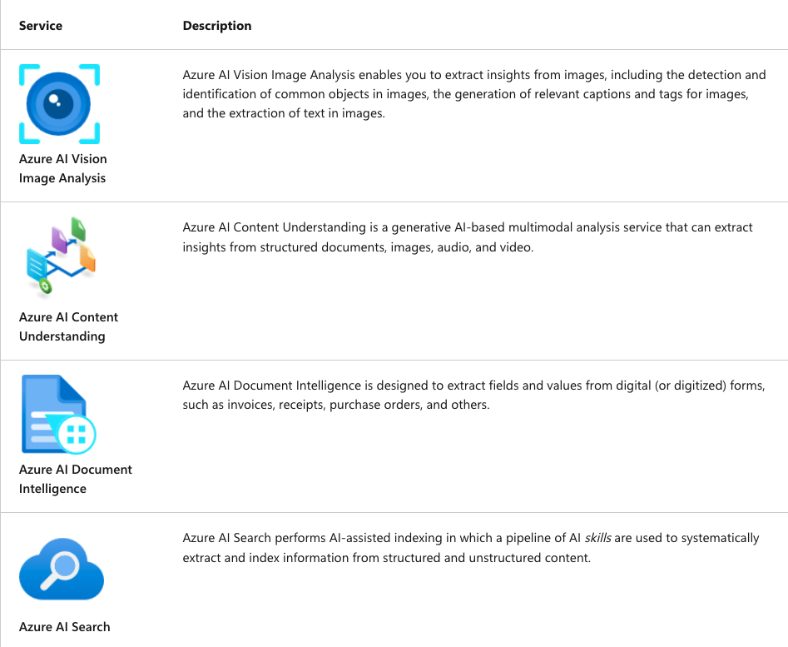
- Use these services to build comprehensive solutions for:
  - Data capture: Intelligently scanning images to capture and store data values (ex. Scan credit card).
  - Business process automation: Reading data from forms and using it to trigger workflows.
    - Ex. extracting cost-centre and billing information from invoices and routing to accounts-payable department for processing.
  - Meeting summarization and analysis: Analyzing and summarizing key points from recorded phone conversations or video conference calls.
  - Digital asset management (DAM): Managing digital assets like images or videos by automatically tagging and indexing them (ex. create a searchable library of stock photographs.
  - Knowledge Mining: Extracting key information from structured and unstructured data to be used for further analysis and reporting.
    - Ex. compiling census data from scanned records to populate a database.

Extract information with Azure AI Vision
- Azure AI Vision Image Analysis (VIA) service can extract insights from photographs or small scanned documents, such as business cards or menus.

Automated caption and tag generation
- VIA can analyze an image and generate:
  - A caption that describes the image.
  - A set of suggested dense captions for the key objects in the image.
  - A collection of tags that help categorize the image.
- Example: Man walking a dog image
  - VIA service generates the following descriptive text values.
    - Caption: A man walking a dog on a leash
    - Dense captions:
      - A man walking a dog on a leash
      - A man walking on the street
      - A yellow car on the street
      - A yellow car on the street
      - A green telephone booth with a green sign
    - Tags:
      - outdoor, land vehicle, vehicle, building, road, street, wheel, taxi, person, clothing, car, dog, yellow, walking, city

Object detection
- VIA can also detect common objects and people in an image.
  - 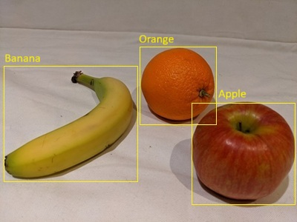

Optical character recognition (OCR)
- When an image contains printed or handwritten text, VIA uses OCR to determine the location and contents of each line of text, and each individual word
  - Possible Use Cases:
    - Read text in an image for processing (ex. translate a menu using a cellphone application).
    - Extract small volumes of free-form text from simple documents (ex. extract contact details from a business card).
- Example: Business Card
  - 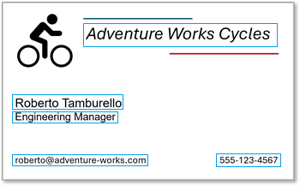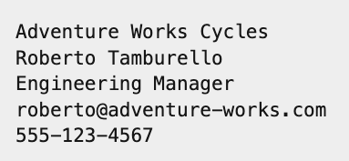

Extract multimodal information with Azure AI Content Understanding
- Azure AI Content Understanding (CU) can analyze content in formats like:
  - Text-based forms and documents
  - Audio, Images, Videos

1) Analyzing forms and documents
- AI CU can extract beyond simple OCR-based text extraction. IT can do schema-based extraction of fields and their values
- Example: Adventure Works Cycling Invoice
- 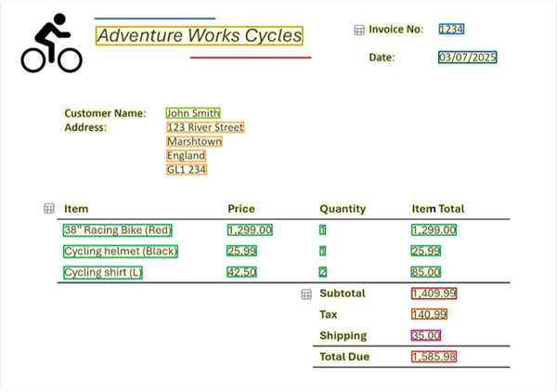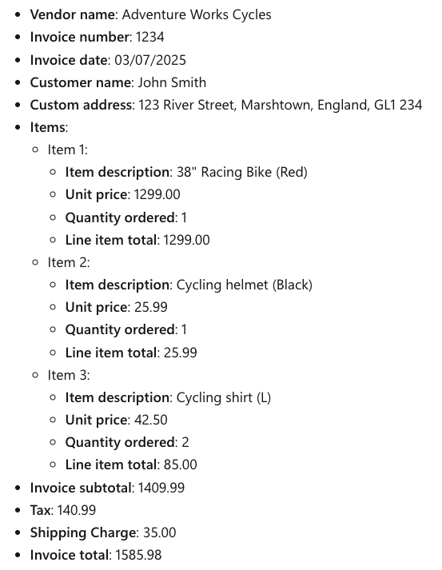
  - Azure AI CU can extract these common invoice fields from the documents

Analyzing audio
- Azure AI Content Understanding is capable of analyzing audio files to provide transcriptions, summaries, and other key insights.
- Example: Extracting from a Voicemail
  - Caller: Ava from Contoso
  - Message summary: Ava from Contoso called to follow up on a meeting and mentioned that they can meet the price expectations. She requested a callback or an email to discuss next steps.
  - Requested actions: Call back or send an email to discuss next steps.
  - Callback number: 555-12345
  - Alternative contact details: Ava@contoso.com

Analyzing images and video
- Azure AI CU could analyze images of a video conference to extract details of attendance, location, and other information.
  - Example: Conference room meeting camera captures a business meeting
    - Location: Conference room
    - In-person attendees: 1
    - Remote attendees: 3
    - Total attendees: 4

Extract information from forms with Azure AI Document Intelligence (DI)
- Azure AI DI supports complex document and form processing scenarios.

Using prebuilt models
Example: Financial loan company needs to hundreds of mortgage applications each day.
- Azure AI DI can extract and locate fields such as:
  - Borrower Name, Address, Telephone number, Social security number, Date of birth, Marital status, Employment status, Employer name, etc.

Create a knowledge mining solution with Azure AI Search

Indexers, indexes, and skills
- Indexer: it defines a repeatable process to:
  - 1) Ingest data from a source
  - 2) Crack documents to extract their contents
  - 3) Apply a sequence of tasks to retrieve info from data and make a hierarchy of fields for the index.
    - Fields can be either core attributes of the source data (ex. Doc file names and last saved dates), or generated by using AI skills.
      - Using Azure AI Vision services to generate tags and captions for images.
      - Using Azure AI Language services to derive fields for sentiment or named entities.
      - Using Azure AI Document Intelligence to extract field values from forms.
  - 4) Persisting the extracted fields as an index.
- CREATES resulting index
  - Enable users to search for info in the extracted fields based on keywords and filtering criteria.

Persisting extracted data to a knowledge store
- Azure AI Search can persist the extracted data assets to a knowledge store. Indexer can save the following kinds of asset in a knowledge store:
    - Tables of field values.
    - Images extracted from documents.
    - JSON documents representing data structures (complex hierarchies of fields and values).

